**Azure Devops:**

**Azure boards: PLAN**

can create tickets ,tasks features based on scrum/ Agile methodology

**Azure repos:** **CODE**

Host the code.similar to github..etc.and also collaborate(branches/PR) on code.

**Git workflows:**

Centralised

Feature branching

Trunk-based

GitFlow

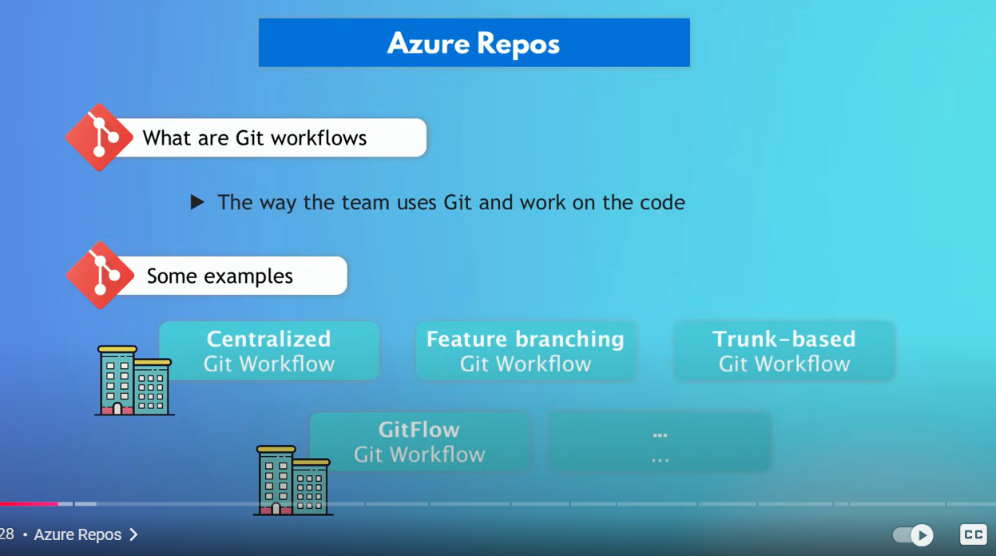

Plan-🡪Code🡪Test🡪Package🡪Deploy

Azure Pipelines: **TEST & PACKAGE (CI)**

**Syntax:**

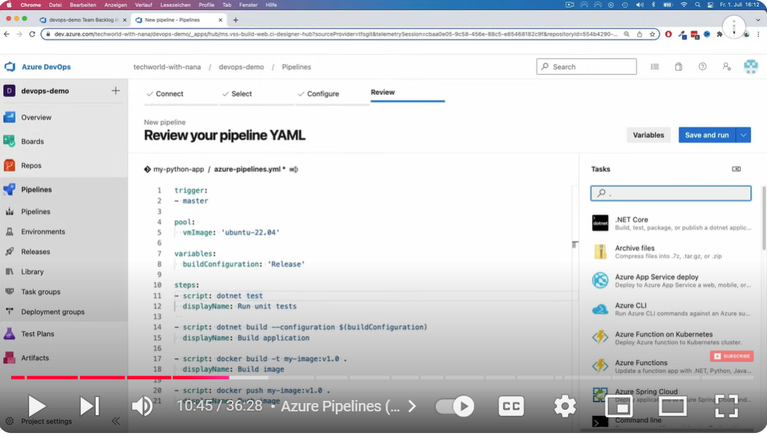

**Single Job:**

We don’t need to explicitly mention a job param if there is only a single job**.**

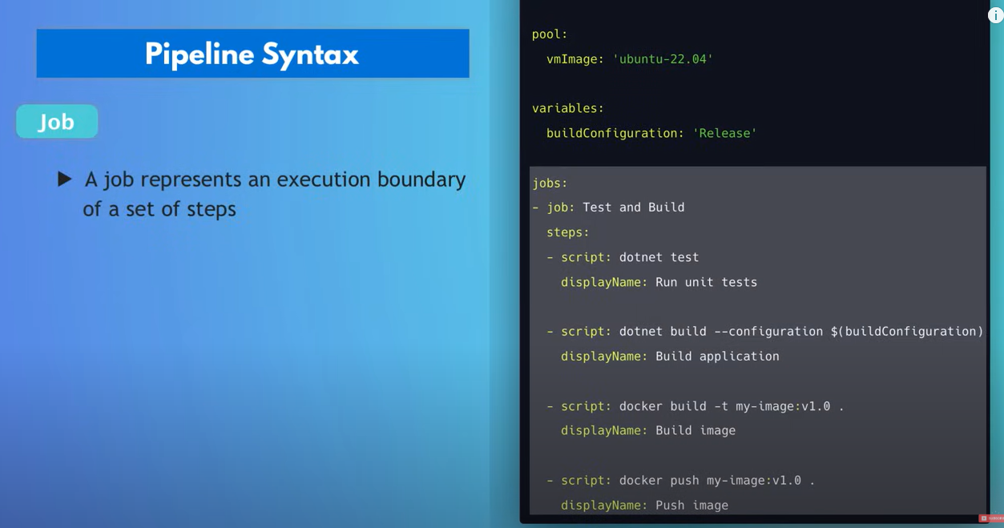

**Multiple Jobs:**

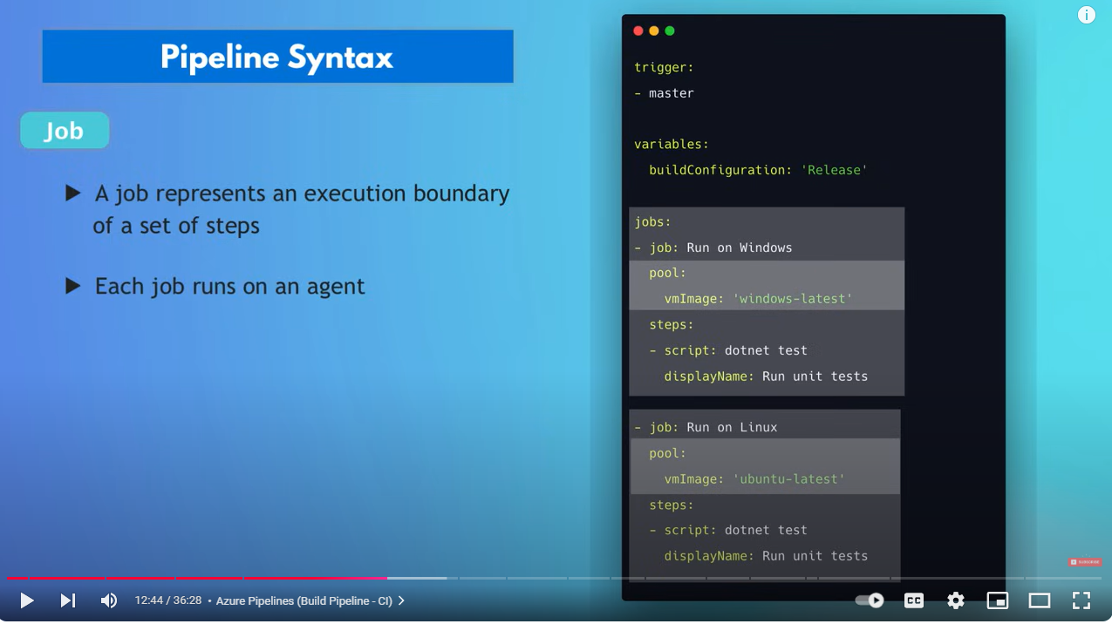

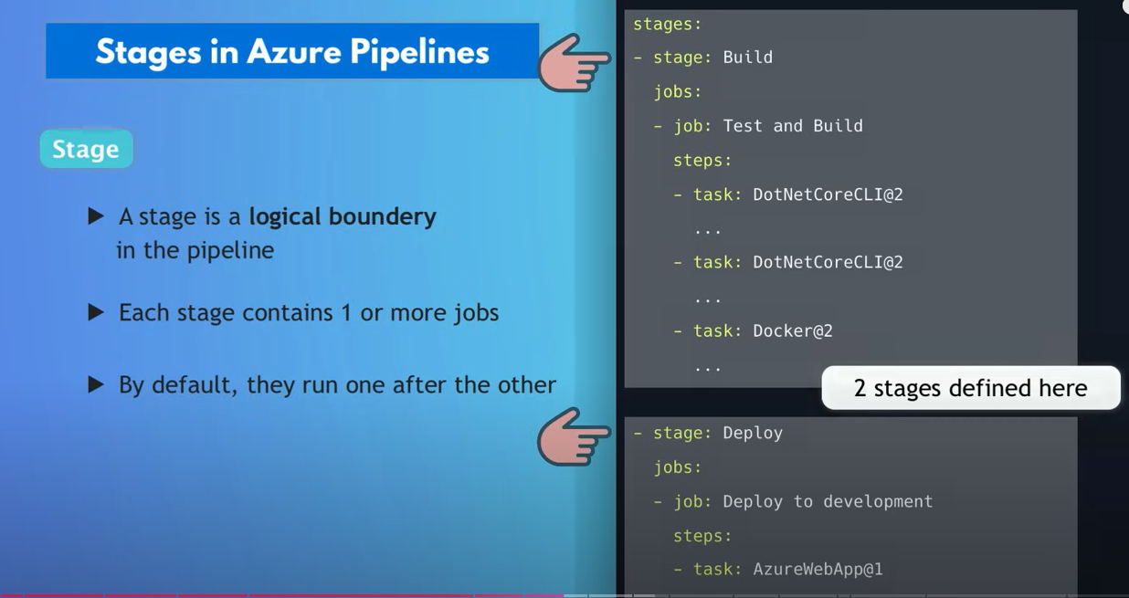

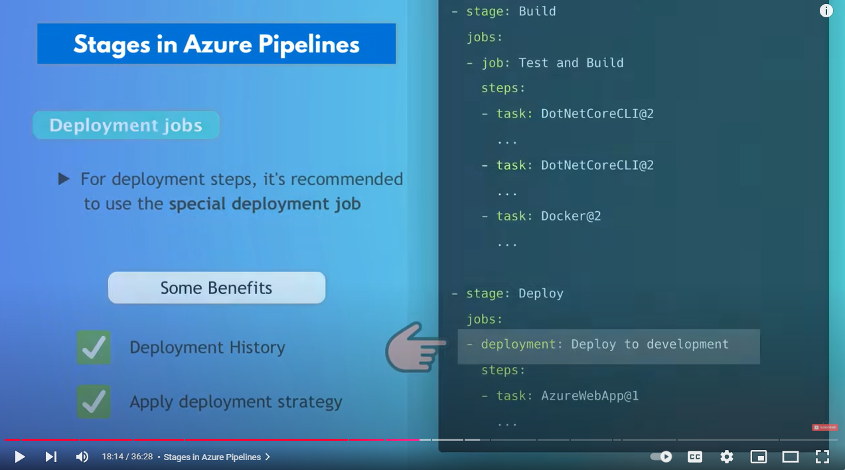

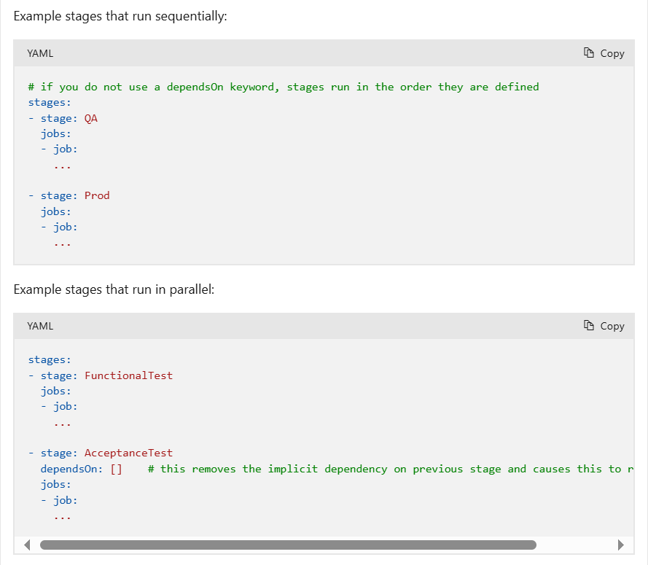

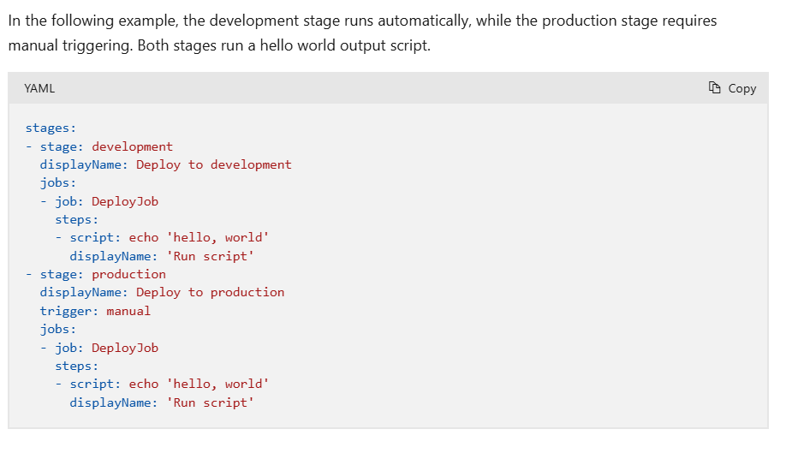

**Azure Artifacts:**

Can store and share different packages.

Based on programming lang used for writing the application.

JAVA🡪JAR

.NET🡪nuget

JS🡪ZIP/TAR

If build pipeline produces **docker images** then DockerHUb/ACR should be used to store the artifact

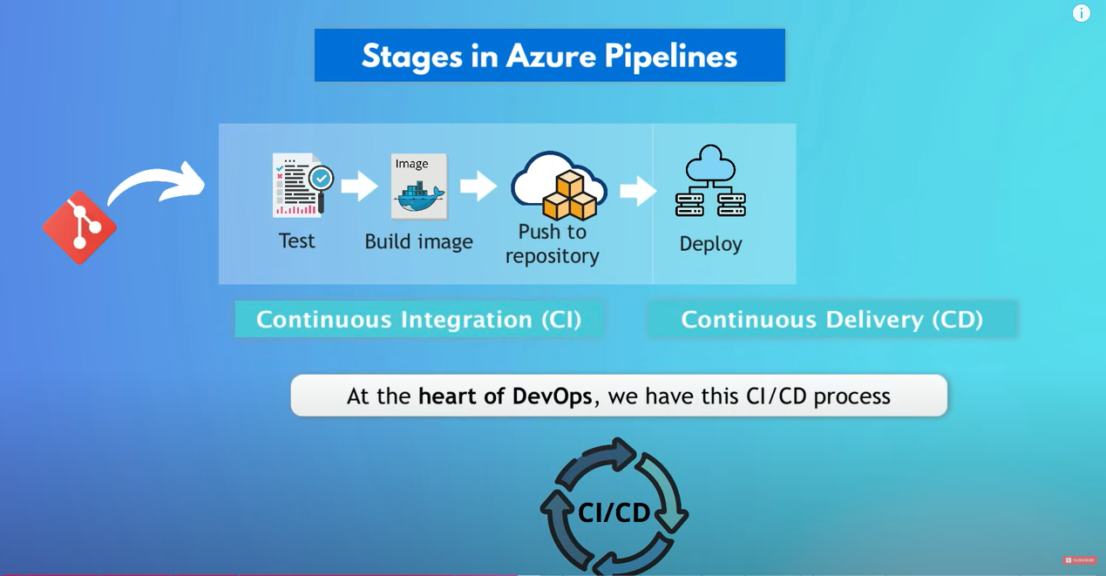

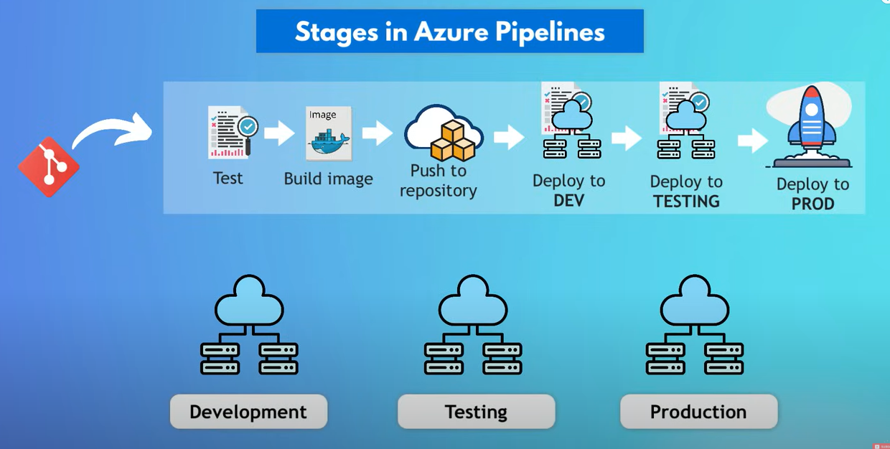

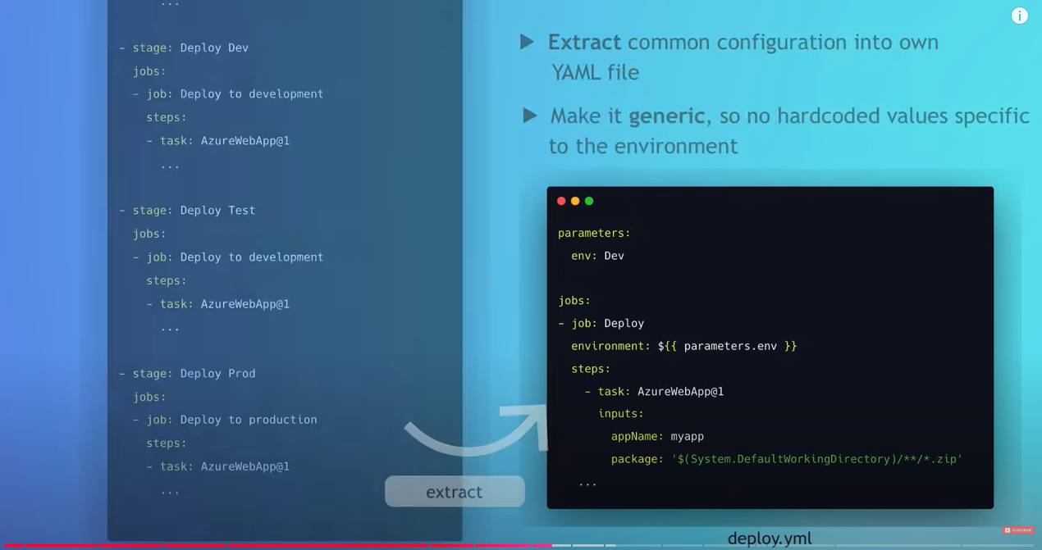

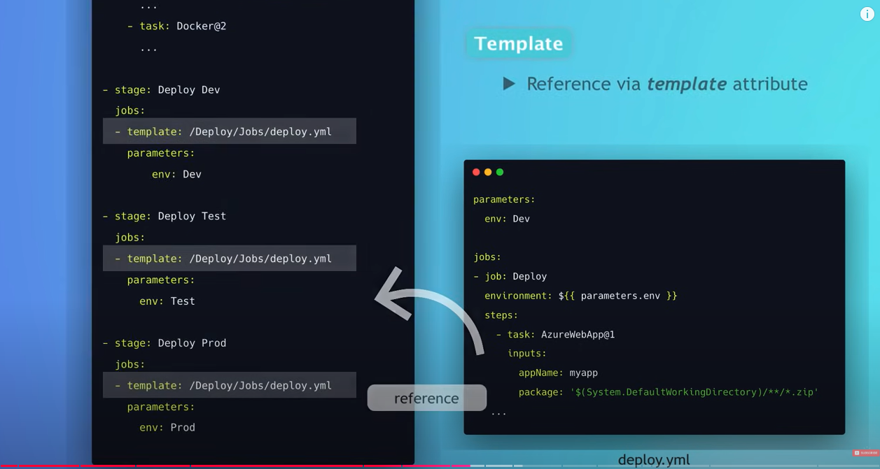

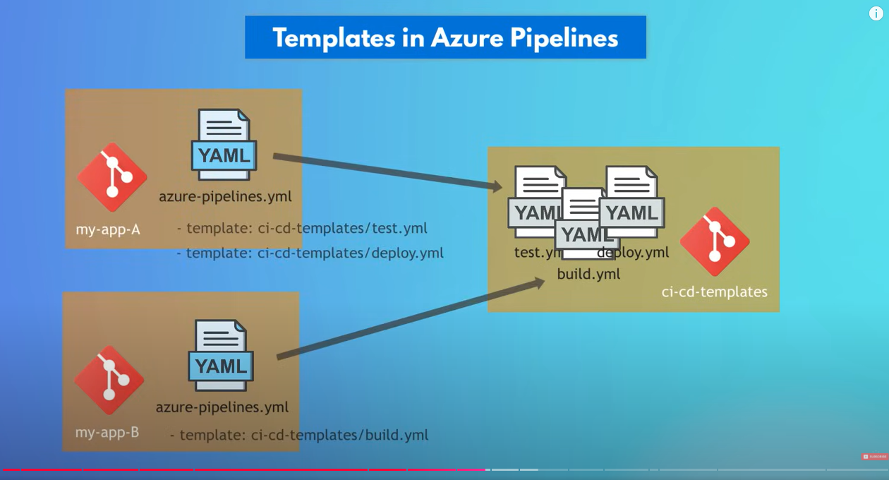

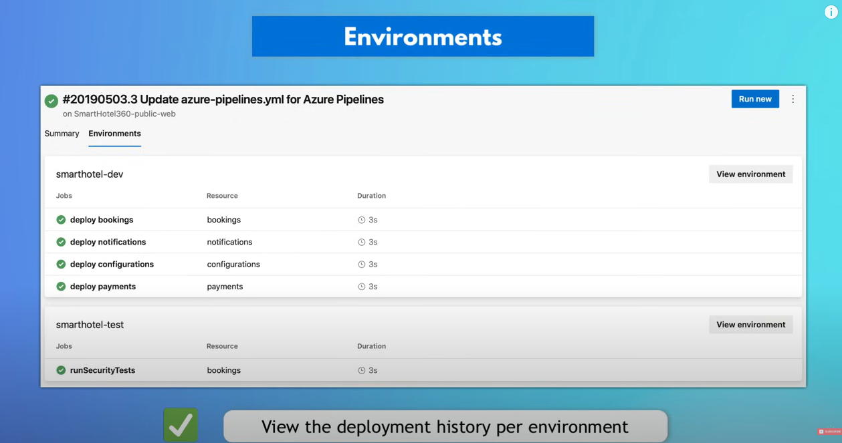

Better to have 1 CI/CD pipeline in YML than having separate pipelines for CI/Cd.

**Test Plans:**

Before code release to end users,need to test the code rigorously.

Manual/automated can be done

Results can be viewed and can be also be run the tests via kanban boards.

**Agents:**

**Microsoft hosted:**

Agents hosted and managed by Microsoft

**Self Hosted:**

An agent that you set up and manage on your own to run jobs.

gives more control to install dependent software needed for your builds and deployments. Also, machine-level caches and configuration persist from run to run, which can boost speed.

**Service connection:**

In devops process we often need to connect and interact with other platforms.

Ex:

Push docker image to container repo.

For that ADO needs to connect and authenticate to these platforms.

**Service hook:**

run tasks on other services when events happen in our ADO project.

Events can be related to Boards/repos/Pipelines.

New item creation /new file commit/build fail notifications to teams/slack ..etc

**Environment:**

An environment is a collection of [resources](https://learn.microsoft.com/en-us/azure/devops/pipelines/process/about-resources?view=azure-devops) that you can target with deployments from a pipeline.

It represents a logical target where your pipeline deploys software. Typical environment names are Dev, Test, QA, Staging, and Production.

**Azure AD:**

Cloud service that provides administrators with the ability to manage end user identities and access privileges.

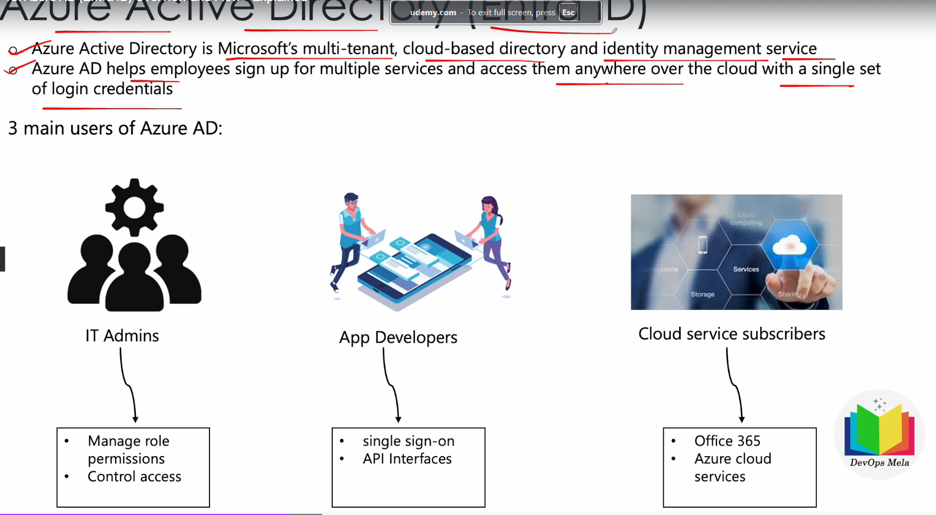

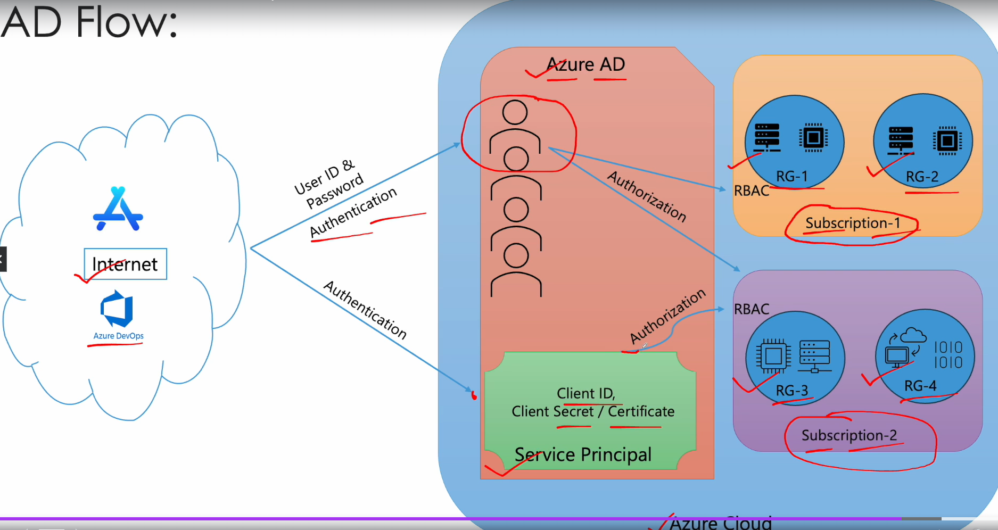

Service Principle.

Connecting to any 3rd party entity

A **Service Principal** in Azure is a security identity used by applications, services, and automation tools to access specific Azure resources. It acts as a bridge between the application and Azure resources, allowing the application to authenticate and perform actions on behalf of itself.

Typical **use cases** where you would rely on a Service Principal is for example when running [Terraform](http://www.terraform.io/?WT.mc_id=devops-10986-petender) IAC (Infrastructure as Code) deployments, or when using [Azure DevOps](http://dev.azure.com/?WT.mc_id=devops-10986-petender) for example, where you define a Service Connection from DevOps Pipelines to Azure; or basically any other 3rd party application requiring an authentication token to connect to Azure resources.

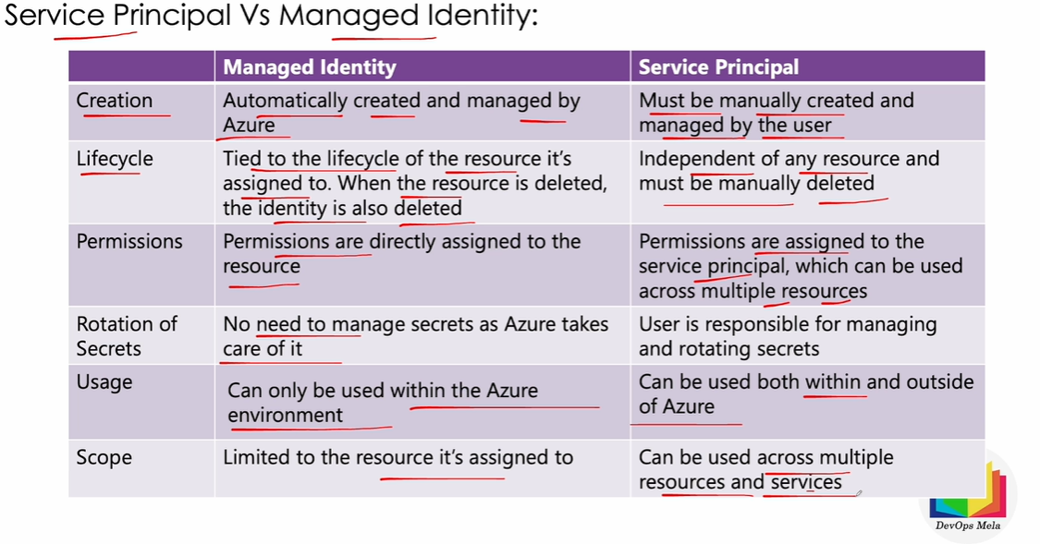

Service connection:

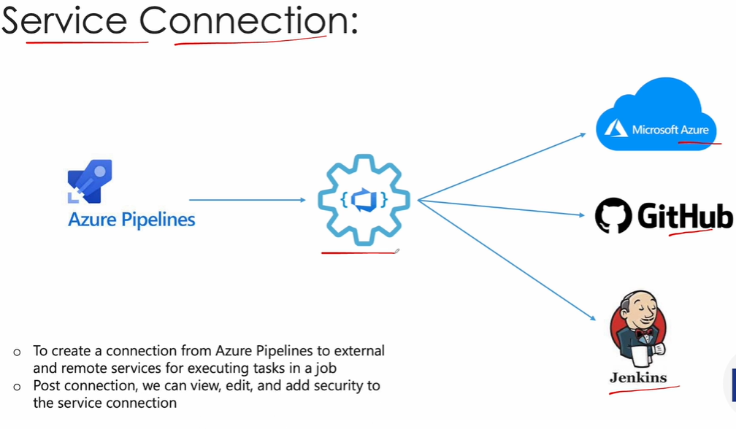

**Azure app service:**

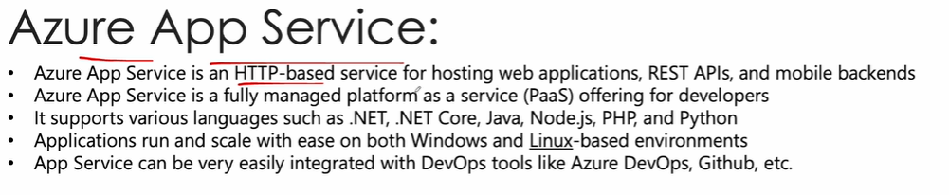

**Continuous Delivery:**

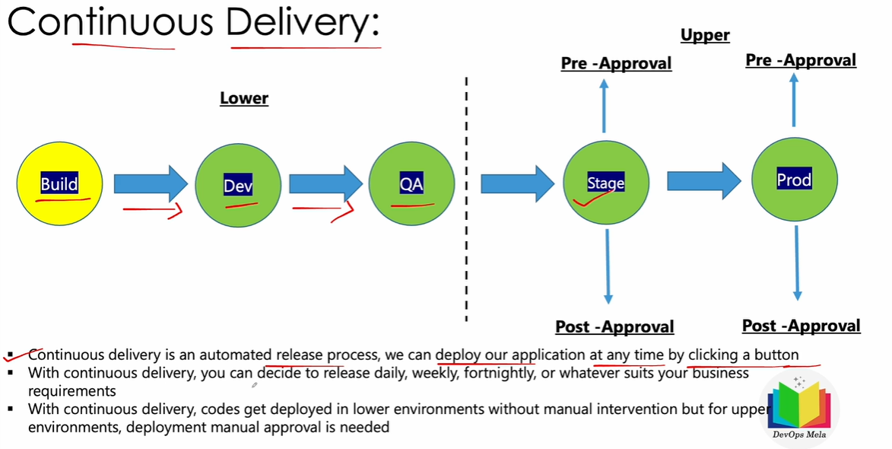

**Continous Deployment:**

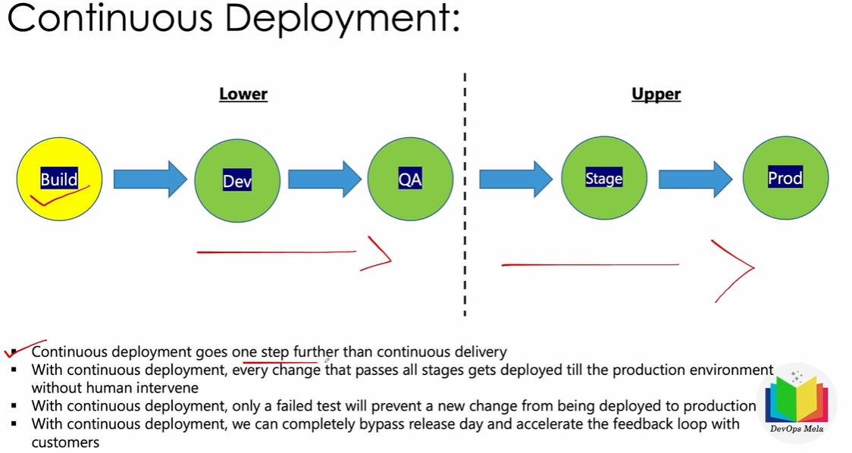

**Deployment groups:**

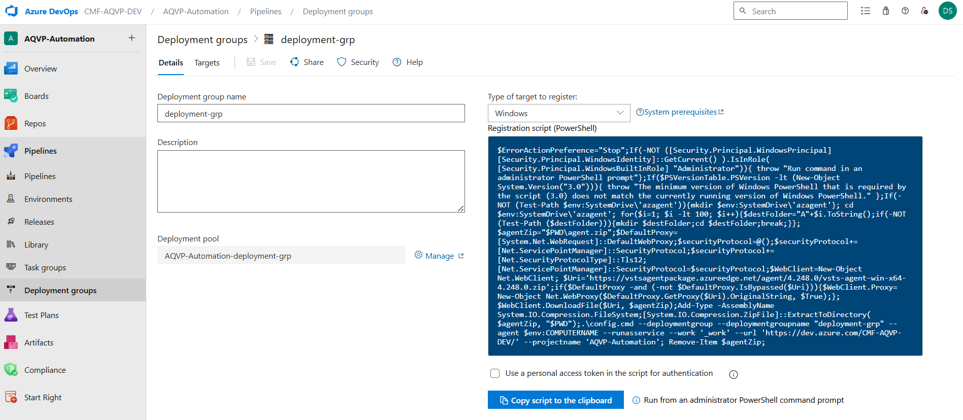

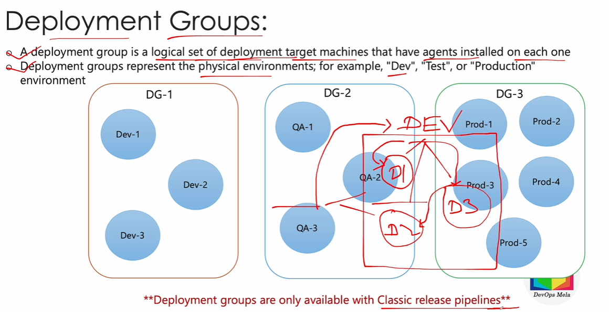

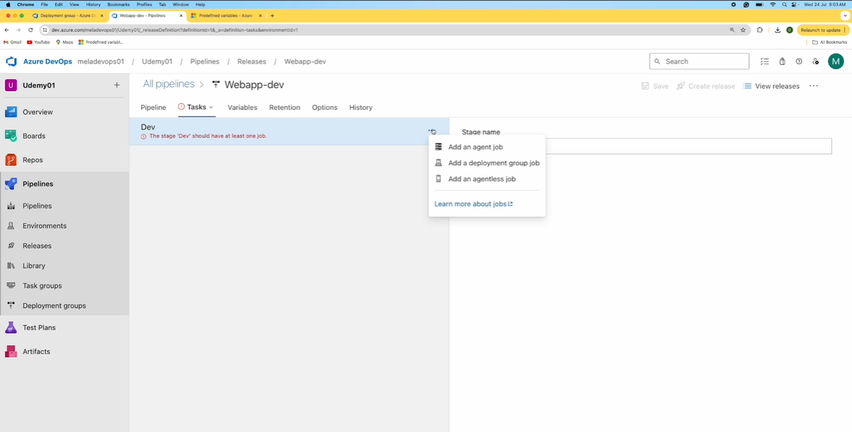

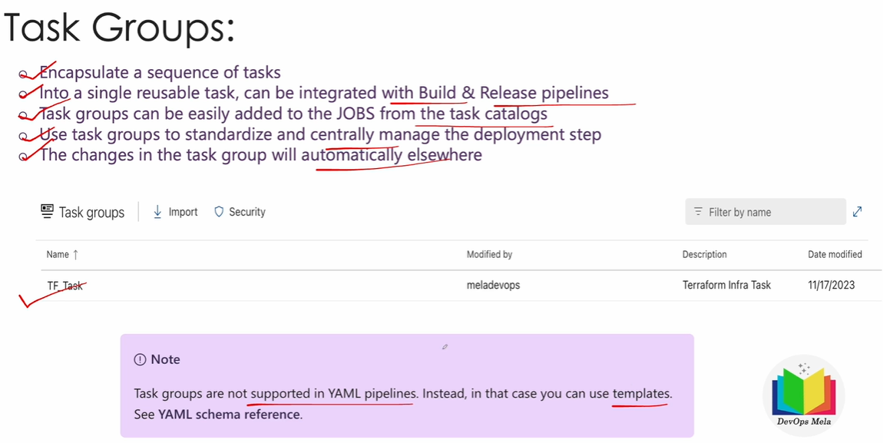

**Build Artifacts vs Pipeline Artifacts…………?????**

